Course: Data Science Roll No: TYCS-12

Aim: Practical on Linear Regression

__________________________________________________________________________________

Outputs: 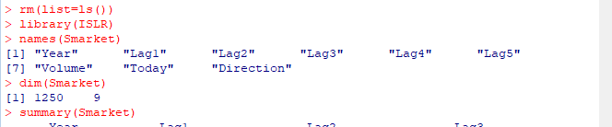

Output 1

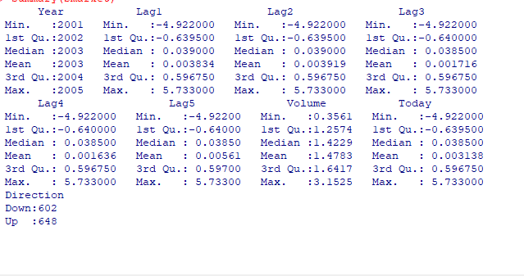

Output 2

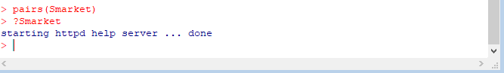

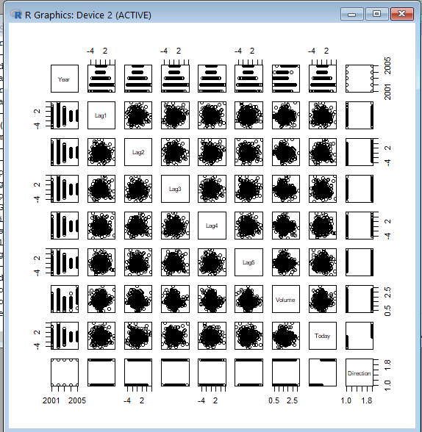

Output 3

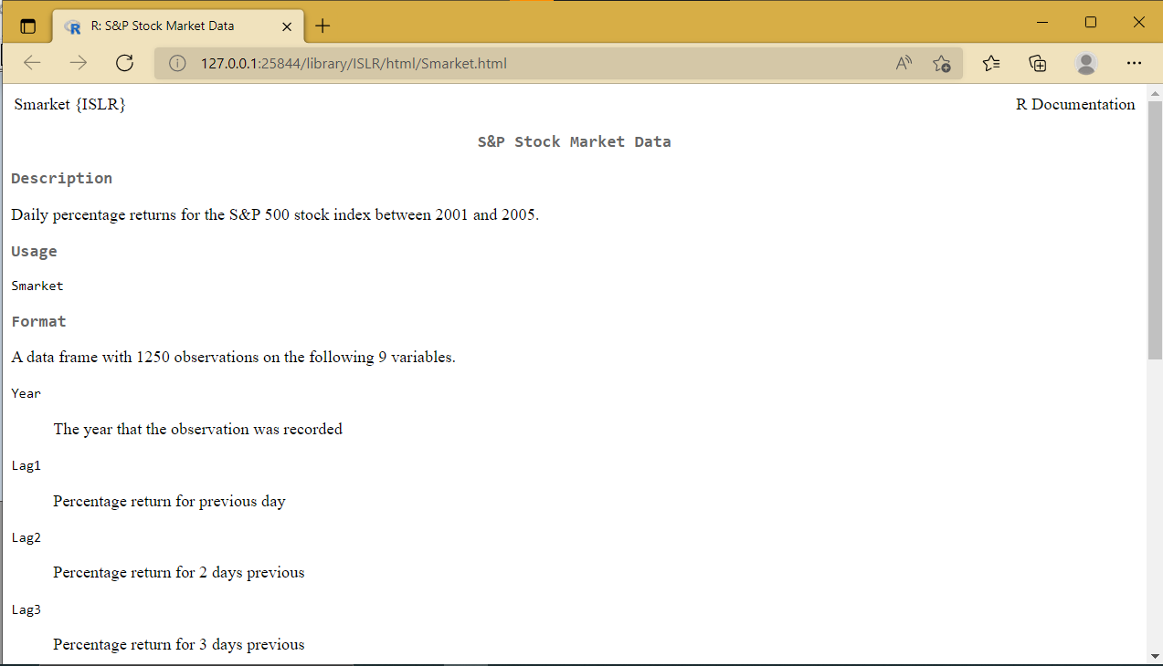

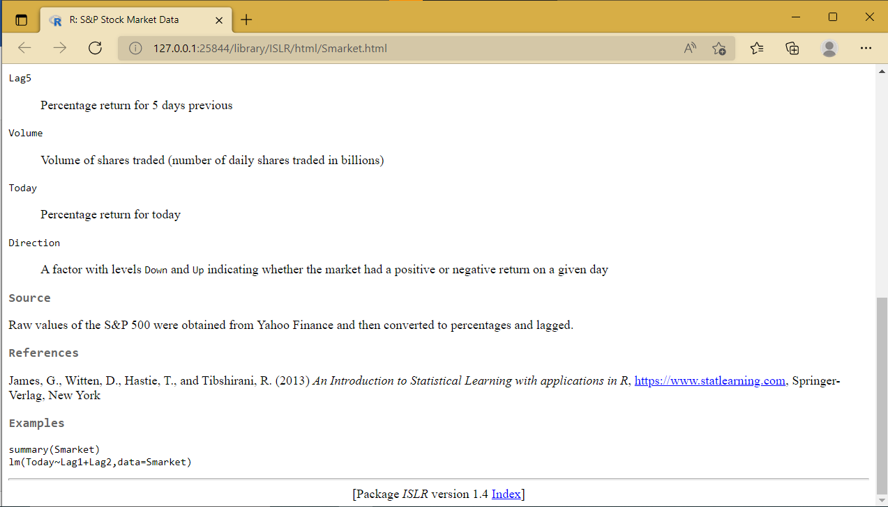

Output 4

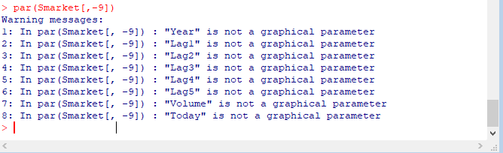

Output 5

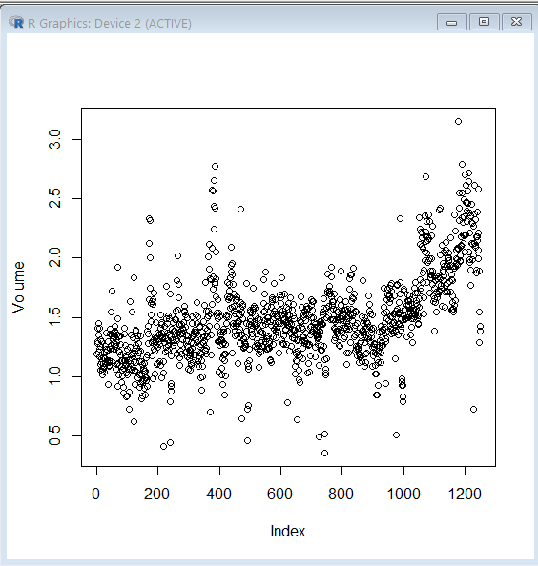

Output6

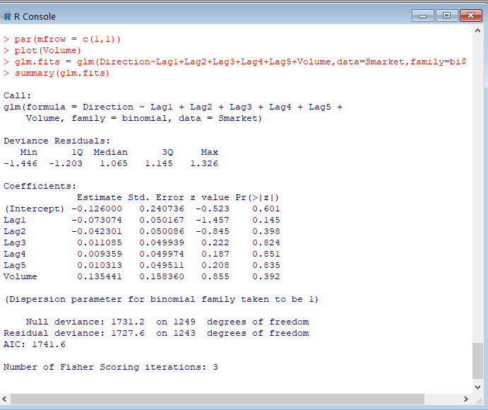

Output 7

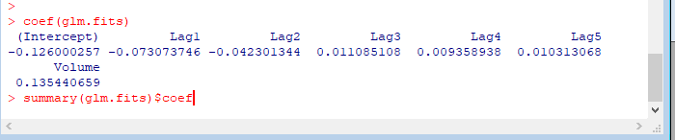

Output 8:

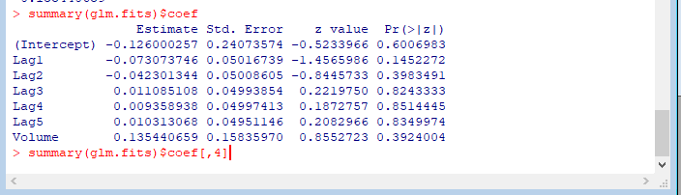

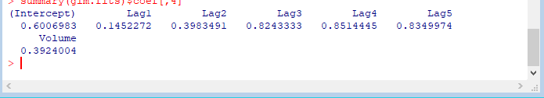

Output 9:

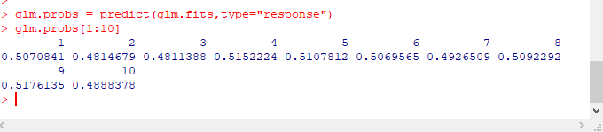

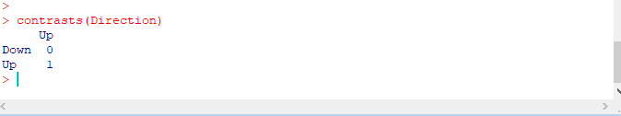

Output 10

